**TOOLS & TECHNIQUES FOR DATA SCIENCE**

**SEMESTER PROJECT**

**FATIMA SHAHEEN MCCS23019**

1. **Load the data in the tool. Briefly explain the dataset [5 marks]**
2. **Dataset Overview**
3. The dataset utilized in this project is a comprehensive global demographic growth dataset sourced from Google Cloud. It encompasses annual population-related indicators for various countries. Each entry in the dataset corresponds to a particular country in a specific year, with the included variables elucidating population dynamics such as birth rates, death rates, migration, and overall growth trends.
4. Upon loading the dataset in Google Colab through PySpark and Pandas, the following columns were accessible:
5. 1. **country_code**
6. A concise alphabetical code that distinctly identifies each country. These codes adhere to established international naming conventions, facilitating efficient merging or comparison of datasets.
7. 2. **country_name**
8. The complete name of the country. This descriptive attribute enhances the interpretability and readability of the dataset.
9. 3. **year**
10. Denotes the calendar year for which the demographic indicators were documented. Given that population metrics fluctuate annually, this field is crucial for conducting time-series analyses, identifying trends, and making growth comparisons.
11. 4. **crude_birth_rate**
12. Represents the number of live births per 1,000 individuals in a specified year. This metric aids in evaluating the rate at which a population is increasing due to births.
13. 5. **crude_death_rate**
14. Indicates the number of deaths per 1,000 individuals in a specified year. This measure is instrumental in understanding mortality trends and assessing population health conditions.
15. 6. **net_migration**
16. Displays the difference between the number of individuals entering a country and those departing from it. A positive figure signifies greater immigration than emigration, whereas a negative figure indicates the contrary.
17. 7. **natural_increase_rate**
18. Determined by subtracting the crude death rate from the crude birth rate.This figure illustrates the rate of natural population change (excluding migration) and indicates whether a nation's population is expanding or contracting based on vital statistics.
19. 8. **population_growth_rate**
20. Indicates the total annual growth rate of the population, which includes both natural increase and migration.This metric is crucial for comprehending long-term demographic patterns and forecasting future population trends.
21. 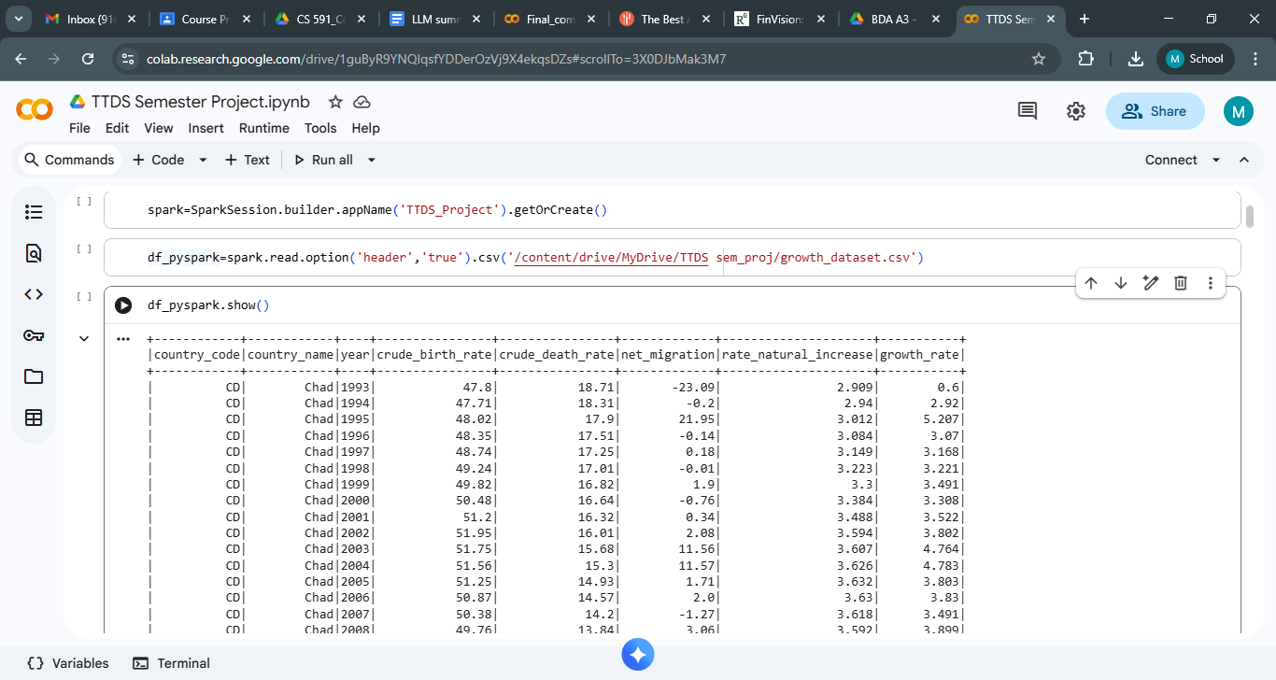
22. **Perform EDA using Python/R. Explain each step [15 marks]**
23. **Checking Column Data Types**

This command provides a list of all column names along with their respective data types.It assists in confirming whether numerical fields (like growth_rate or crude_birth_rate) are accurately identified as numeric values or incorrectly loaded as strings.Should any discrepancies arise, suitable type conversions can be implemented subsequently.



1. **Displaying the Schema**

This function displays the dataset schema in a hierarchical format.It offers a more comprehensive perspective of each column, encompassing data type and nullability (indicating whether the column can hold missing values).This process is crucial for comprehending the data structure and strategizing transformations or statistical analyses.



1. **Displaying the First Few Records**

This command presents the initial five rows of the dataset.It provides a brief overview of the actual data values, assists in identifying formatting problems, missing values, or atypical entries, and confirms that the dataset has been loaded accurately.

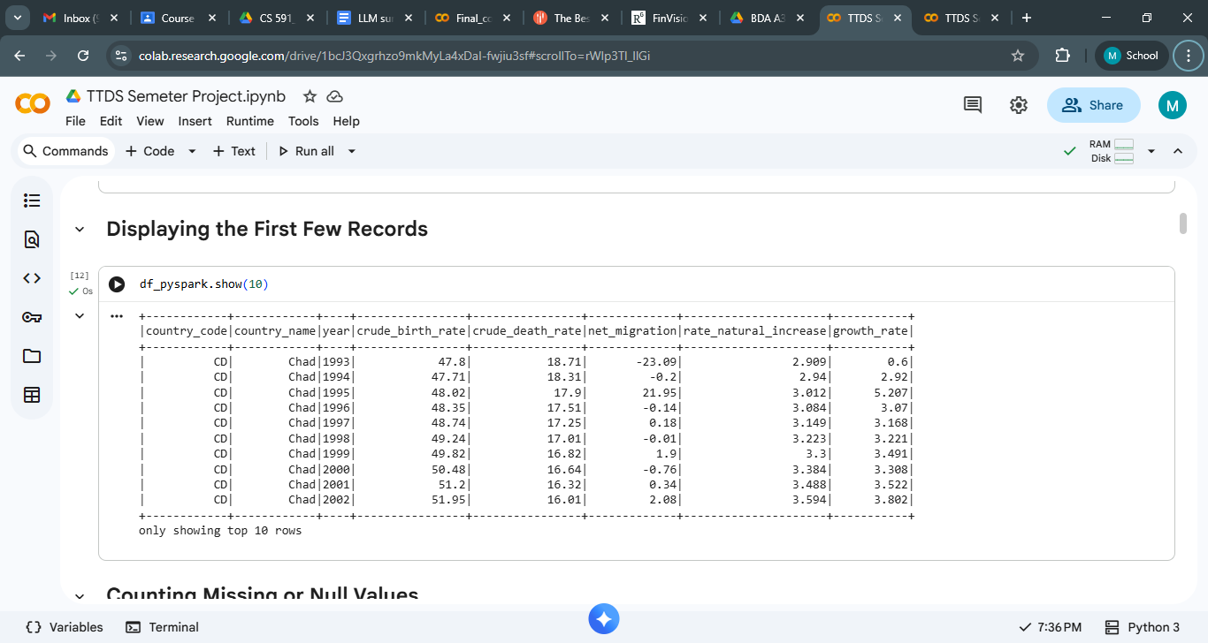

1. **Counting Missing or Null Values**

This step computes the count of null or missing values in each column.Recognizing missing data early on aids in determining whether to clean, impute, or eliminate problematic rows.It also guarantees data quality prior to additional processing.

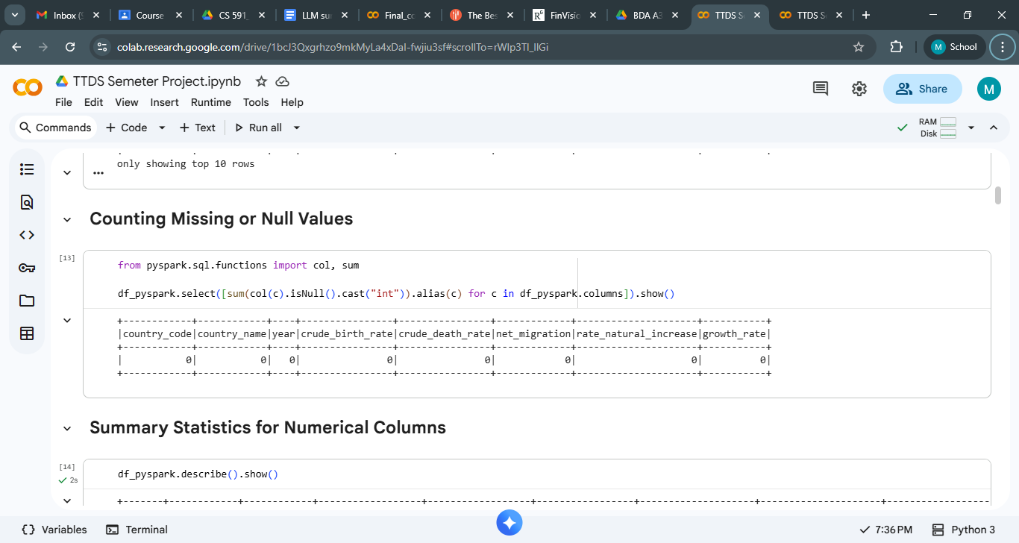

1. **Summary Statistics for Numerical Columns**

This command produces summary statistics—such as count, mean, minimum, maximum, and standard deviation—for all numerical columns. These statistics offer insights into the distribution of values, identify outliers, and assist in understanding the overall data range and central tendencies.

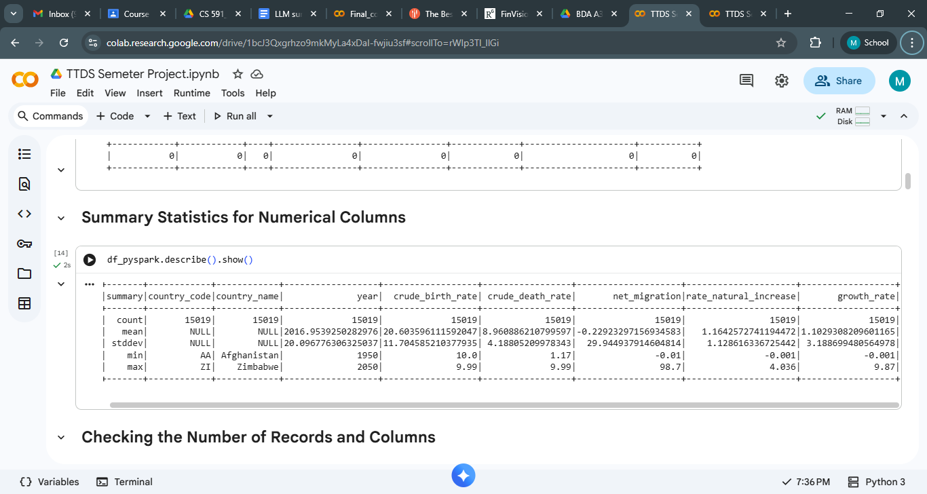

1. **Checking the Number of Records and Columns**

This step provides the total count of rows and columns within the dataset.It verifies the size of the dataset and aids in determining whether the data is adequate for meaningful analysis. Understanding the number of records is also crucial for estimating the computational load in PySpark.

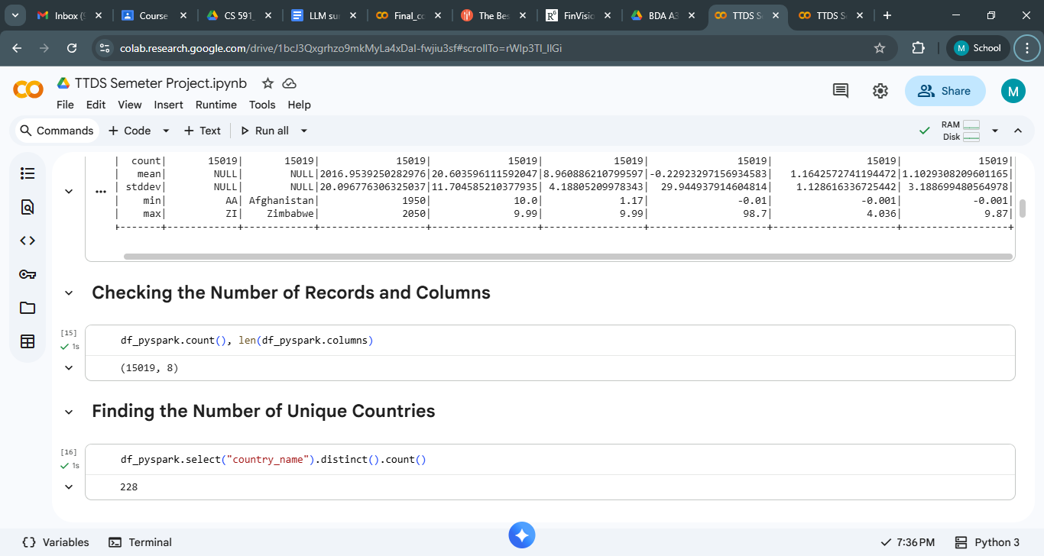

1. **Finding the Number of Unique Countries**

This indicates the number of distinct countries included in the dataset.

It aids in comprehending the dataset's global reach and guarantees that it is not confined to a limited number of regions.This process is beneficial when conducting comparisons or clustering at the country level.



1. **Checking Distribution of Growth Rate**

This process offers valuable descriptive statistics for the growth_rate column.Grasping the distribution of growth rates assists in determining whether the majority of countries are experiencing steady growth, encountering decline, or exhibiting significant fluctuations.

It also facilitates the identification of anomalies, such as exceptionally high or low growth, which may necessitate further examination.

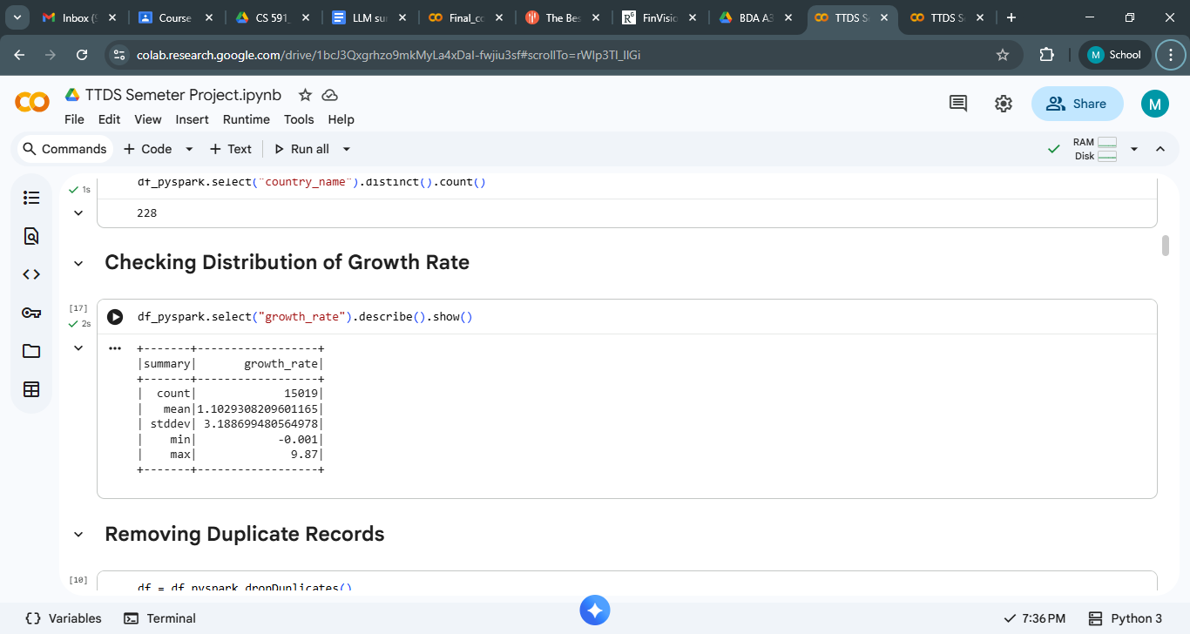

1. **Data wrangling/cleansing etc. Explain each step [15 marks]**
2. **Removing Duplicate Records**

Duplicate entries can skew statistical analyses and misrepresent trends.This procedure guarantees that each country-year entry is represented only once, thereby enhancing the integrity of the dataset.

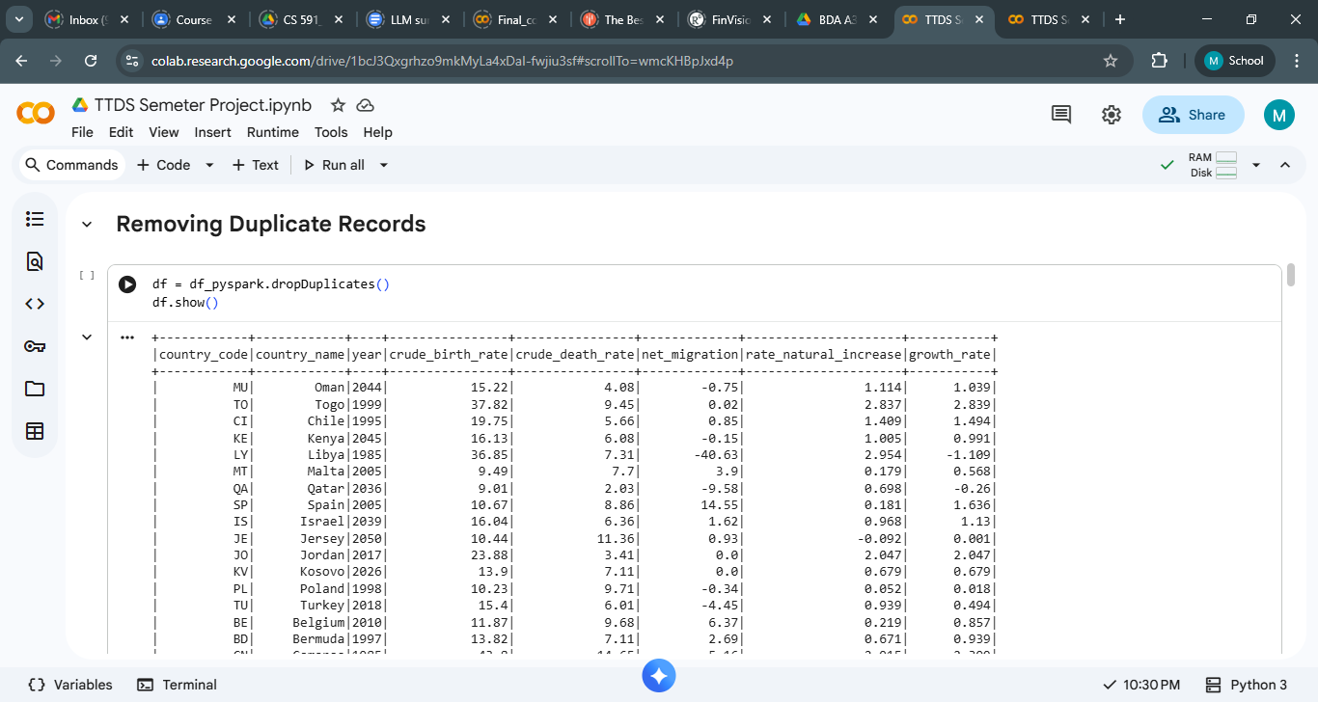

1. **Removing Missing Values**

This procedure eliminates all rows that have missing (null) values. Missing values can lead to errors in calculations, skew summary statistics, and diminish the reliability of the analysis. By removing incomplete rows, the dataset is rendered more consistent and appropriate for further investigation.

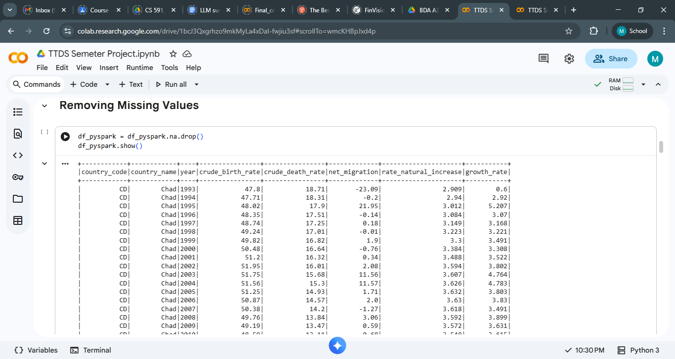

1. **Removing Null Values**

This action discards rows that exhibit null values in particular columns or throughout the entire dataset. This guarantees that all variables utilized for analysis possess valid entries and averts complications during mathematical computations or graphical representations.

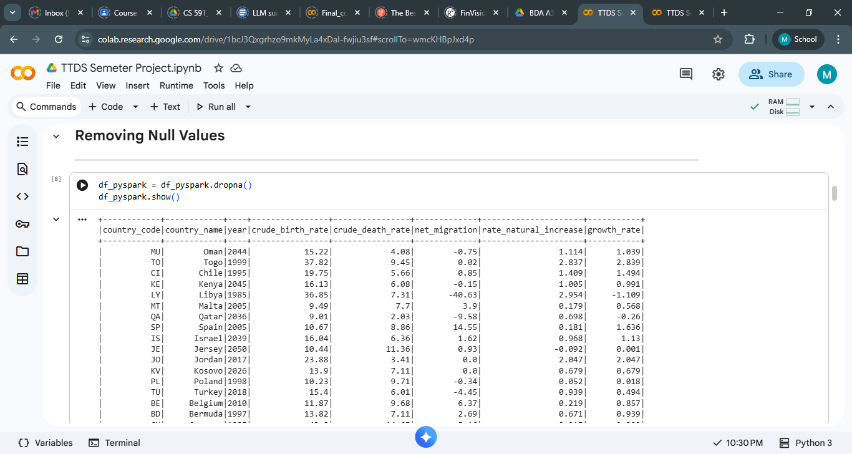

1. **Converting Data Types**

Datasets imported from CSV files frequently treat numerical values as strings. This process transforms designated columns into appropriate numeric formats. Accurate data types are crucial for executing mathematical operations, correlations, and visualizations.

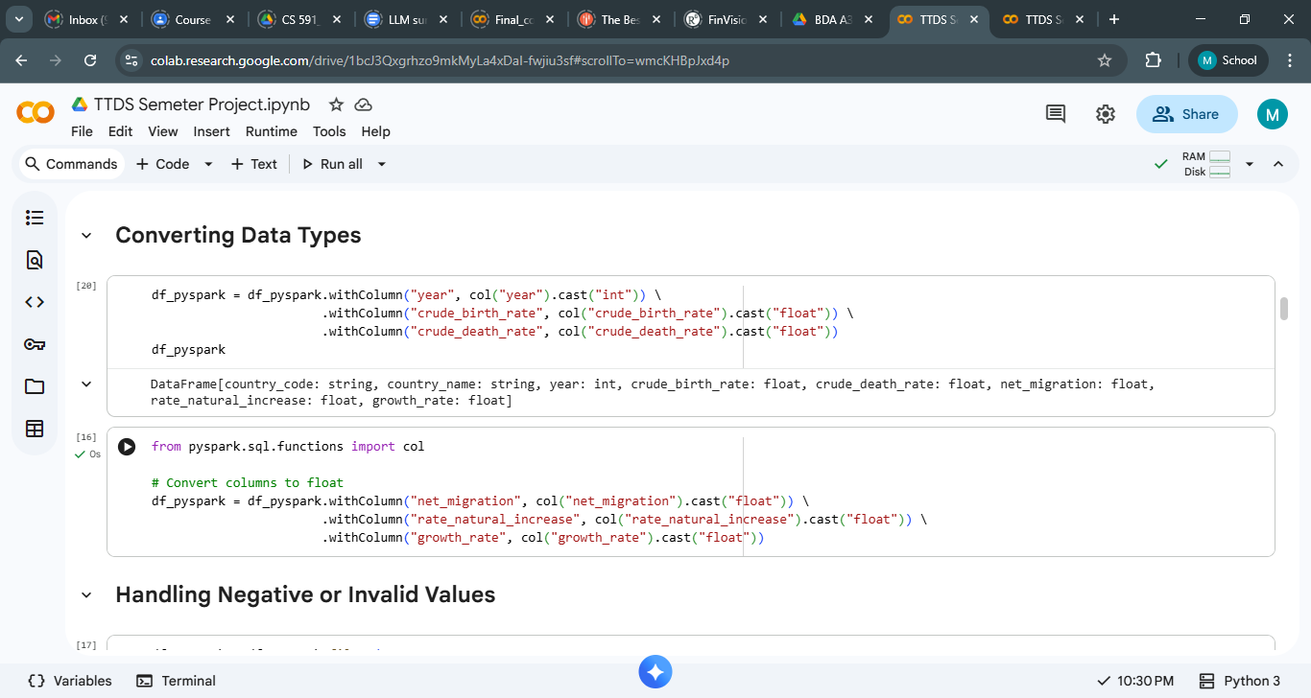

1. **Handling Negative or Invalid Values**

Certain fields, including growth_rate and crude_birth_rate, should typically not have unrealistic negative values.This process eliminates or filters out invalid entries, enhancing the accuracy and reliability of the dataset.

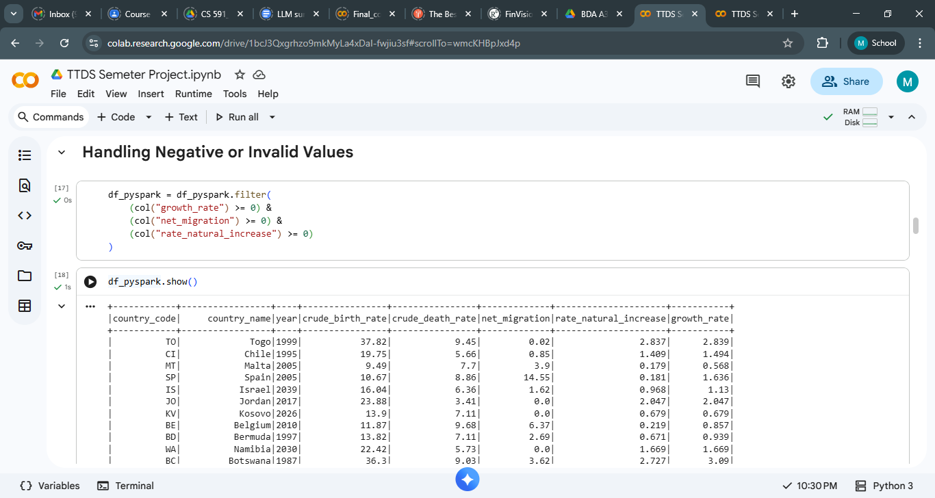

1. **Creating Derived Columns**

Derived columns provide further insights.For instance, the natural growth gap indicates whether a country's population is experiencing natural growth or decline.Feature engineering readies the data for predictive modeling and more in-depth analysis.

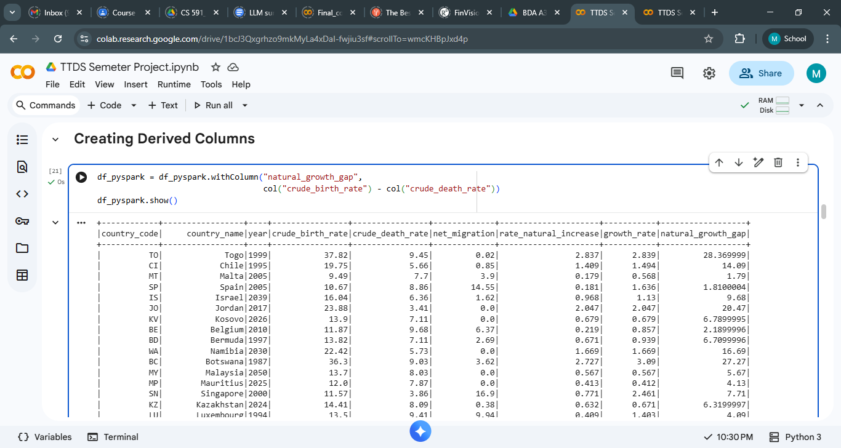

1. **Build multiple charts using Python/R. Explain observations [15 marks]**
2. **Growth Rate WRT Country Name**

The line chart depicts the fluctuations in growth rates among a diverse array of countries. In general, the majority of countries seem to have growth rates that are closely aligned with zero, suggesting a state of relatively stable or moderate economic growth. Nevertheless, a number of countries demonstrate notable spikes—both upward and downward—that diverge from the overall trend.

One of the most prominent irregularities is the exceptionally high positive and negative growth figures linked to Mauritius, which reveal sharp deviations when compared to all other nations. These extreme variations may suggest the presence of data anomalies, outliers, or extraordinary economic occurrences during particular years. Likewise, a handful of other countries show moderate spikes, yet none attain the level of intensity seen in Mauritius.

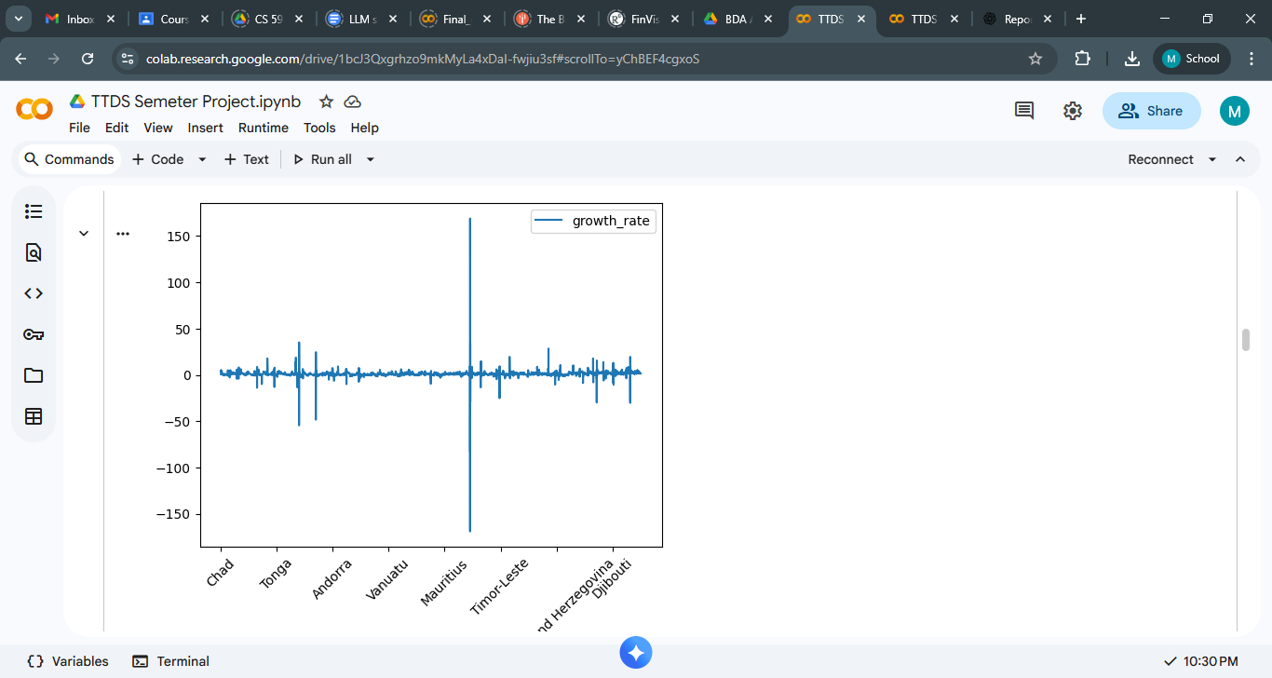

1. **Growth Rate Wrt Year**

The line chart illustrates the changes in the growth rate over time, spanning from the mid-20th century to the anticipated years following 2020. Throughout the majority of this timeline, growth rates are relatively stable and hover around zero, signifying gradual or moderate fluctuations. Nevertheless, a pronounced increase and decrease are observed from the late 1990s to the early 2000s, during which the growth rate experiences significant positive and negative spikes. These sudden changes indicate the existence of notable outliers or extraordinary events that led to substantial variations in the dataset during that period.

Subsequent to this timeframe, the growth rate once again stabilizes, reverting to a narrow range akin to that of previous decades. In summary, the trend underscores that while most years demonstrate stable growth, the early 2000s emerge as a notably volatile period that may necessitate additional analysis or data validation.

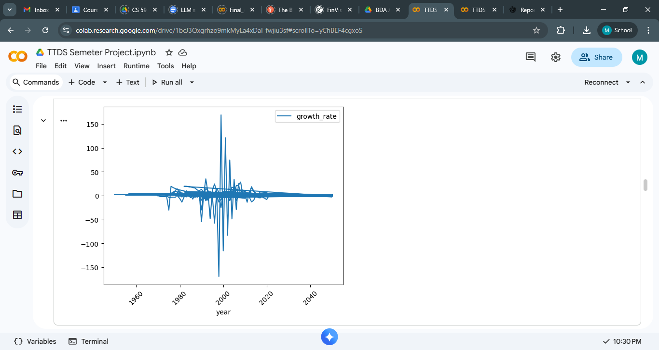

1. **Birth Rate and Death Rate wrt Country Name**

This chart illustrates the comparison between the crude birth rate and the overall growth rate across different nations. The birth rate, represented by the blue line, typically remains within a moderate and stable range for the majority of countries, signifying relatively consistent population birth trends. Conversely, the growth rate, depicted by the red line, displays significantly lower values and experiences more pronounced fluctuations.

A notable spike—both highly positive and negative—can be observed for Mauritius, which distinctly stands out from the other data points. This peculiar deviation indicates the likelihood of outliers or anomalies in the growth rate statistics for that particular country. While some other nations exhibit similar, albeit smaller, fluctuations, none achieve the same level of intensity.

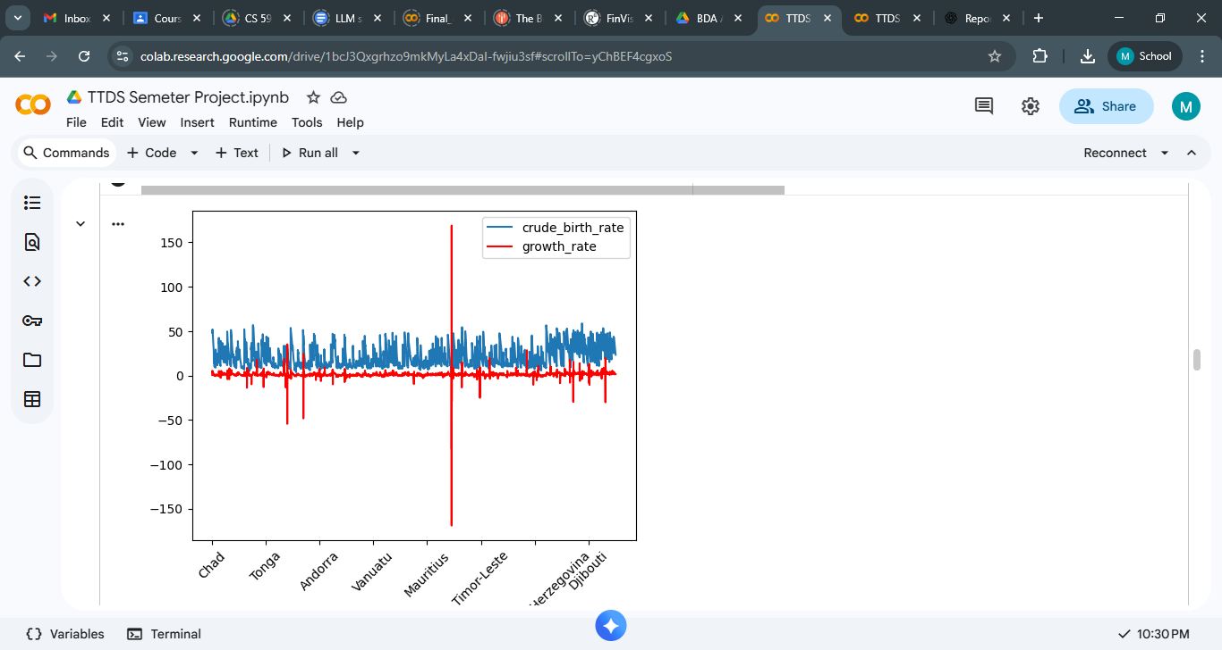

1. **Net Migration and Birth rate wrt year**

The stacked bar chart depicts the correlation between the crude birth rate and net migration from 2001 to 2021. The crude birth rate (represented by blue bars) demonstrates a consistent downward trajectory throughout this timeframe, signifying a gradual reduction in the number of births over the years. This trend reflects enduring demographic changes, such as declining fertility rates or alterations in population composition.

Net migration (illustrated by green bars) exhibits considerable fluctuations over the years, encompassing both positive and negative figures. The initial years reveal substantial negative migration figures, indicating a significant exodus of individuals. In subsequent years, the net migration figures become less pronounced, although they continue to vary, suggesting ongoing but more tempered migration activity.

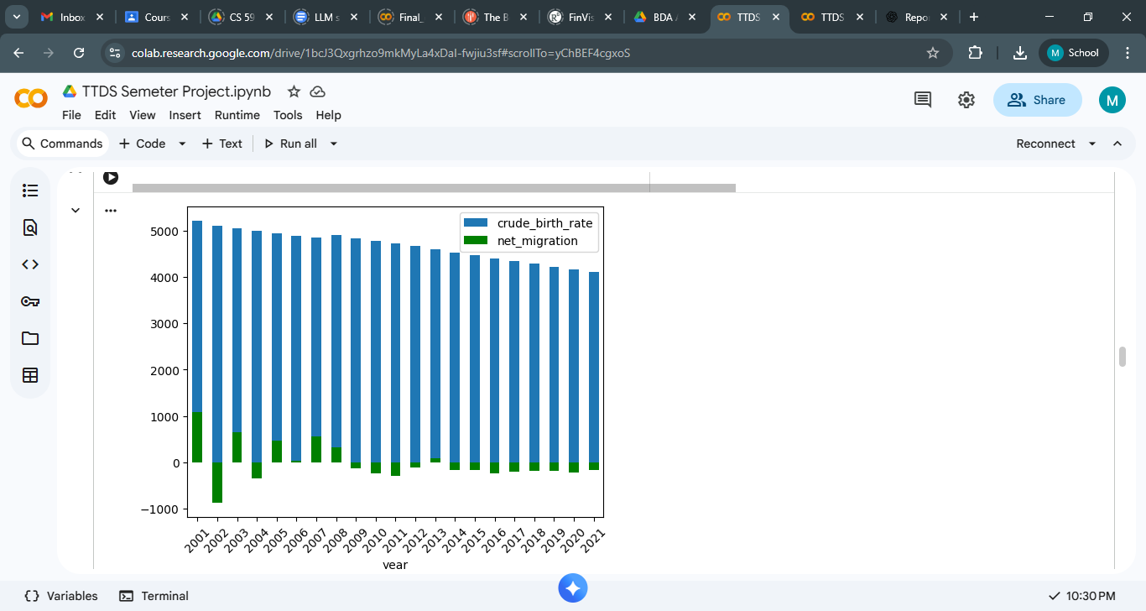

1. **Net Migration and Birth Rate wrt Country**

The bar chart illustrates the comparison of crude birth rates and net migration among various countries. The crude birth rate (represented by blue bars) exhibits significant variation, with certain nations—such as Afghanistan and Angola—demonstrating markedly higher birth rates in contrast to others like Andorra, Austria, and Belgium, which present relatively lower figures. This disparity highlights demographic variations, including fertility trends and population growth dynamics.

Net migration (depicted by green bars) displays sharp fluctuations across different countries, encompassing both positive and negative values. Nations such as American Samoa and Armenia report substantial negative migration figures, indicating a significant outflow of population. Conversely, countries like Andorra, Anguilla, and Bahrain reflect positive migration values, implying an influx of individuals.

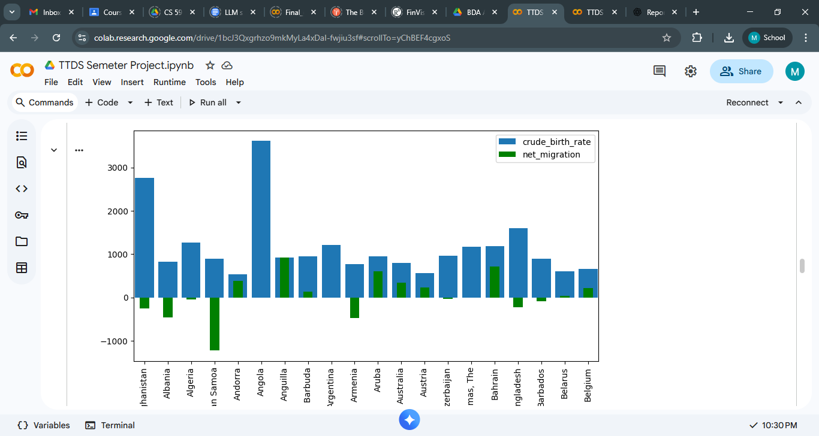

1. **Growth rate and Death rate wrt Country**

The chart illustrates the comparison between growth rates and crude death rates across various countries, highlighting distinct differences in population dynamics.Crude death rates (represented by green bars) are generally higher than growth rates (indicated by blue bars) in most countries, suggesting that mortality exerts a more substantial influence on population change than natural growth alone.

Countries like Afghanistan, Angola, and Bangladesh exhibit relatively elevated death rates alongside moderate growth rates, implying demographic pressures or health-related issues.Conversely, certain nations—including American Samoa and Belarus—demonstrate negative or very low growth rates despite having moderate death rates, indicating a trend of population decline.

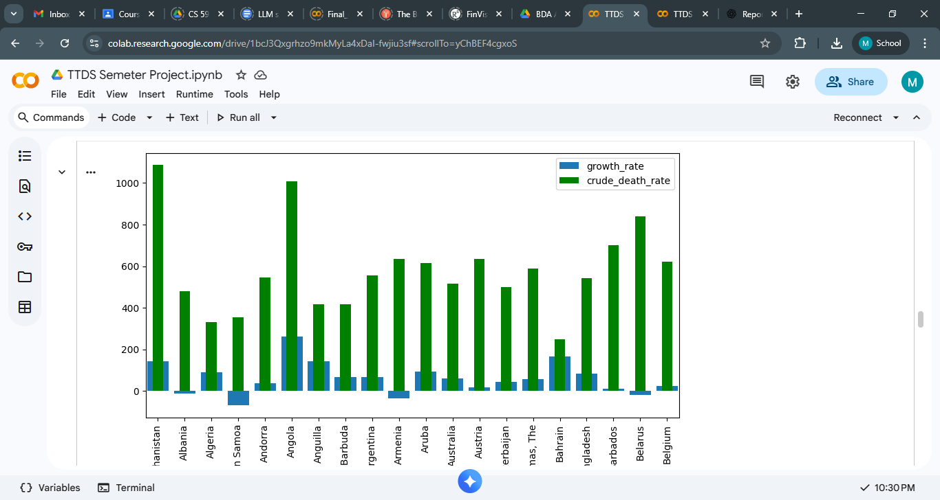

1. **Birth rate and Rate of natural increase**

The chart depicts the correlation between the crude birth rate and the natural increase rate over time, revealing a distinct upward trajectory in both metrics. Crude birth rates exhibit a steady rise from the initial years, experiencing a sharp increase during the mid-period and peaking in the later years, which implies a continuous rise in population births over time. The natural increase rate demonstrates a similar, albeit more gradual, upward trend, suggesting that population growth is consistently bolstered by increasing birth rates. While the natural increase remains considerably lower in magnitude than the crude birth rate, both factors exhibit parallel growth patterns, indicating a robust and positive demographic momentum throughout the years observed.

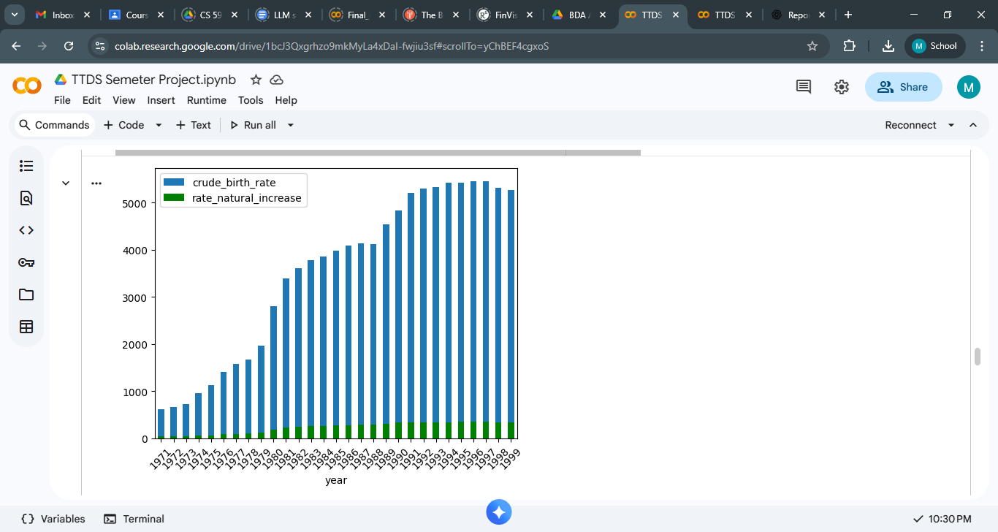

1. **Net Migration wrt Country**

The chart illustrates net migration trends among various countries, demonstrating generally slight variations for the majority of nations, with figures tending to cluster around zero.

Nevertheless, several countries exhibit significant spikes in both positive and negative directions, signifying periods of considerable population influx.One particular country—Mauritius—distinguishes itself with an exceptionally large positive spike alongside a significant negative drop, indicating extreme migration occurrences or potential data irregularities for that area.

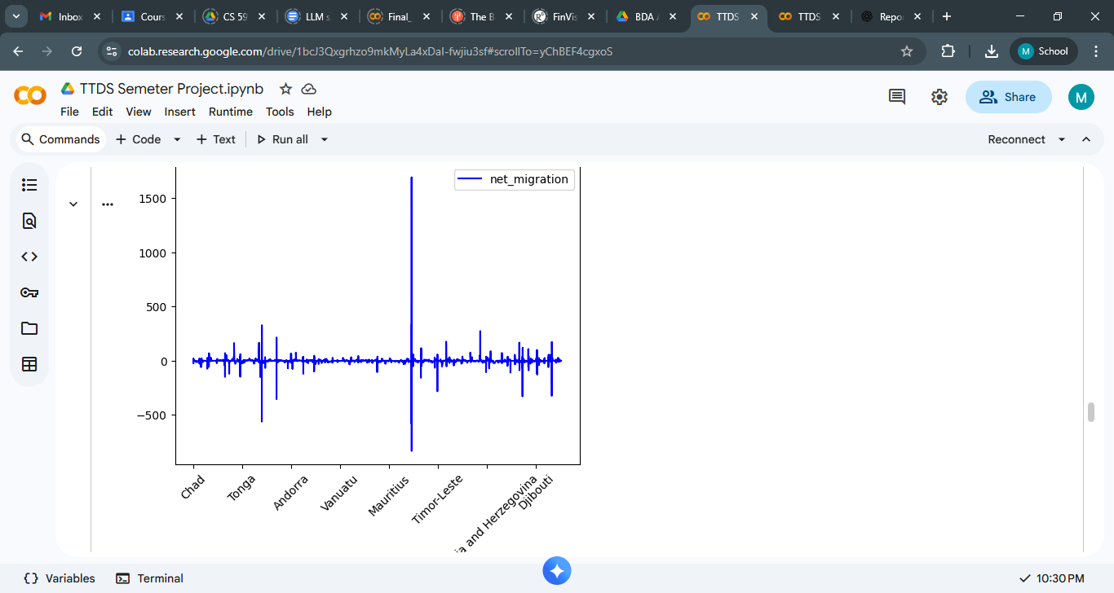

1. **Birth rate and Growth Rate wrt country**

1. The Crude Birth Rate Remains Consistently Elevated and Stable: The blue line representing the crude birth rate predominantly fluctuates between 10 and 50, varying by country.

This suggests:

Most nations sustain moderate to high birth rates.

There are no significant fluctuations, indicating a degree of stability.

2. The Growth Rate Exhibits Significant Variability: The green line (growth_rate) varies between 0 and 5 for the majority of countries.

Nevertheless, there are notable outliers:

Certain nations experience abrupt and substantial spikes (such as Mauritius in the chart).

Others encounter sharp negative declines (also in the vicinity of Mauritius/Timor-Leste).

These anomalies frequently arise from:

Sudden shifts in migration patterns

Data irregularities

Political or environmental occurrences (conflicts, disasters, refugee movements)

3. Various Countries Display Unique Population Dynamics

Some observable trends:

Countries with High Birth Rates

Chad

Djibouti

Vanuatu

These nations exhibit consistently elevated blue lines → indicating stronger fertility rates.

Countries with Low Birth Rates / Stable Population

Andorra

Mauritius

These countries generally show lower blue lines → reflecting reduced fertility.

4. Notable Outliers in Growth Rate

The pronounced spikes near Mauritius and Timor-Leste imply:

Significant migration events (either positive or negative)

Issues with data entry (frequently seen in global population statistics)

These require rectification or additional scrutiny.

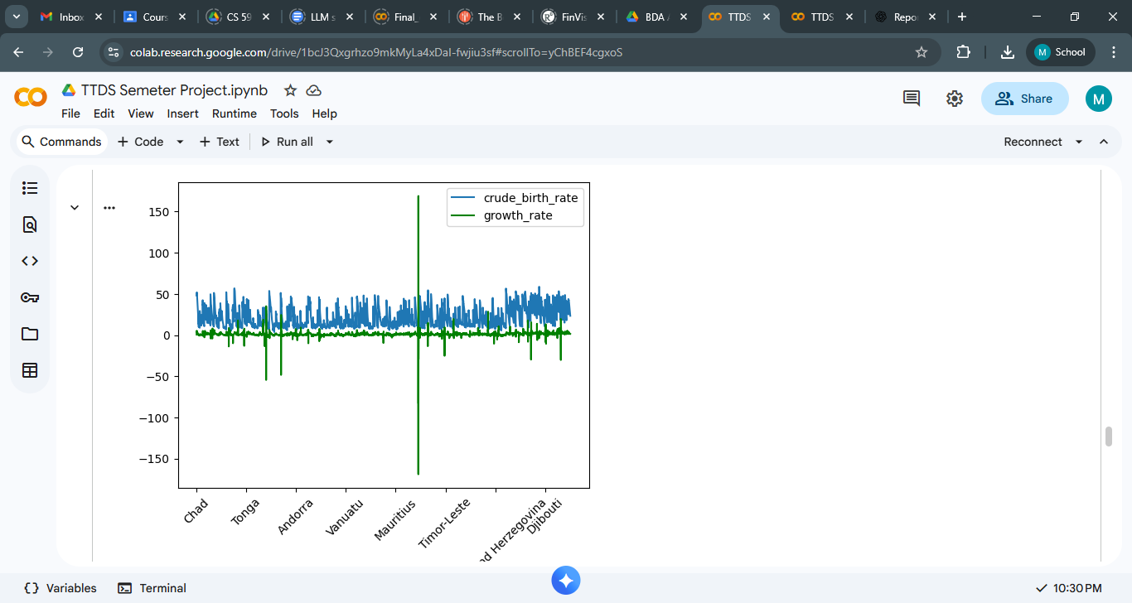

1. **Net Migration and Growth wrt Country**

Steady Increase in the Early Years (1981–1988):From 1981 to 1988, the crude birth rate exhibits a steady upward trajectory, increasing from approximately 3400 to over 4100.This indicates enhanced population growth, elevated fertility rates, or social conditions that supported larger families.

Sharp Surge (1988–1991):During the period from 1988 to 1991, there is a notable increase, with figures escalating from around 4100 to approximately 5200.

Such an increase may be attributed to:

Policy modifications that promote births

Economic advancements.

Migration trends that augmented the population of individuals in childbearing age.

High Plateau (1991–1997):From 1991 onwards, the birth rate remains consistently elevated, typically ranging between 5200 and 5500.This phase signifies sustained high fertility or a considerable influx of population.

Slight Decline at the End (1998–1999):The final two years demonstrate a slight reduction from the peak, decreasing to about 5300 by 1999.

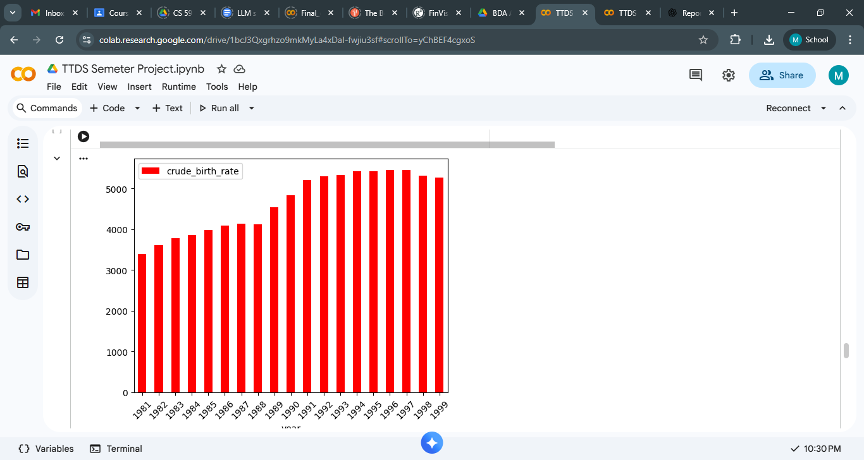

1. **Death Rate wrt Year**

Early Increase (1990–1994):The crude death rate exhibits a gradual increase during the early 1990s, peaking around 1994–1995.

Stable High Plateau (1995–1999):From the mid-1990s through the late 1990s, the figures remain relatively elevated and stable, signifying a period characterized by consistently high death rates.

Gradual Decline (2000–2010):Following the peak of the late 1990s, there is a consistent downward trajectory throughout the 2000s. This indicates advancements in healthcare, improvements in living standards, or other socio-economic developments.

Slight Fluctuation but Overall Decline (2010–2019):From 2010 to 2019, the crude death rate continues to decline, although the pace of this decline diminishes. The figures seem to stabilize at a lower level in comparison to the 1990s.

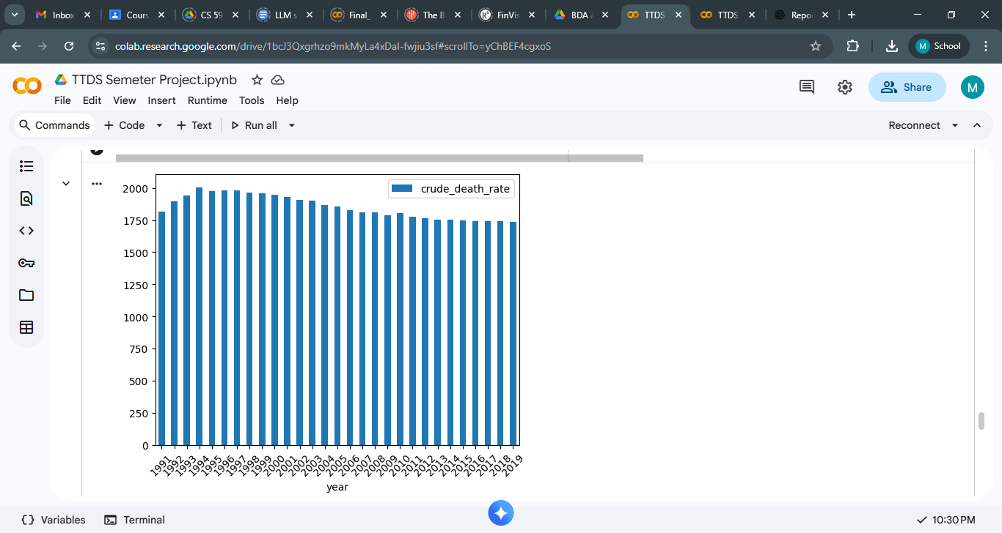

1. **Box Plot to see different Data Distrubution**

The box plot offers a comparative analysis of the distributions of all significant variables within the dataset, emphasizing differences in scale, variability, and the existence of outliers.Most indicators—such as the crude birth rate, crude death rate, rate of natural increase, and growth rate—demonstrate relatively compact distributions characterized by moderate spread and few extreme values.

In contrast, net migration displays a considerably broader range with numerous outliers extending in both positive and negative directions, signifying high volatility and substantial variation across different countries or years.The year variable is observed to be tightly clustered, which is anticipated from a sequential time-based field.

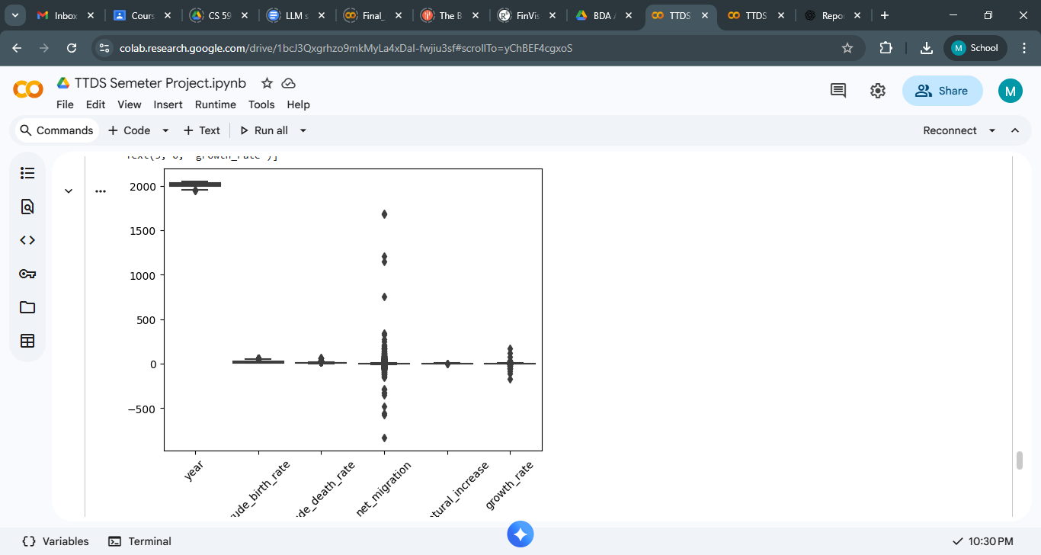

1. **Use of Git [15 marks]**
2. **Creating Git Reposiotory**
3. 
4. **Link Local Repository to Github Repository and pushing code to it**
5. 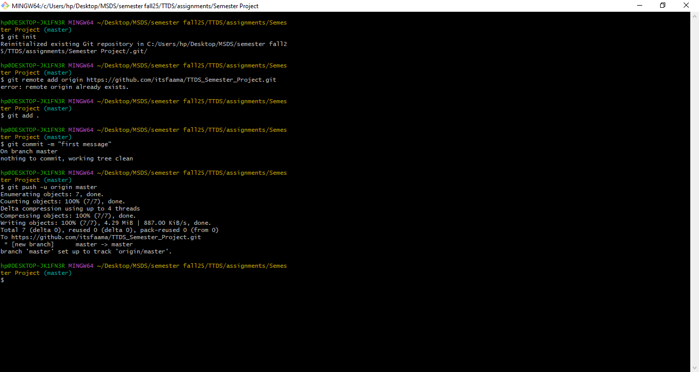
6. 
7. **Git Commit to make changes to the code**
8. 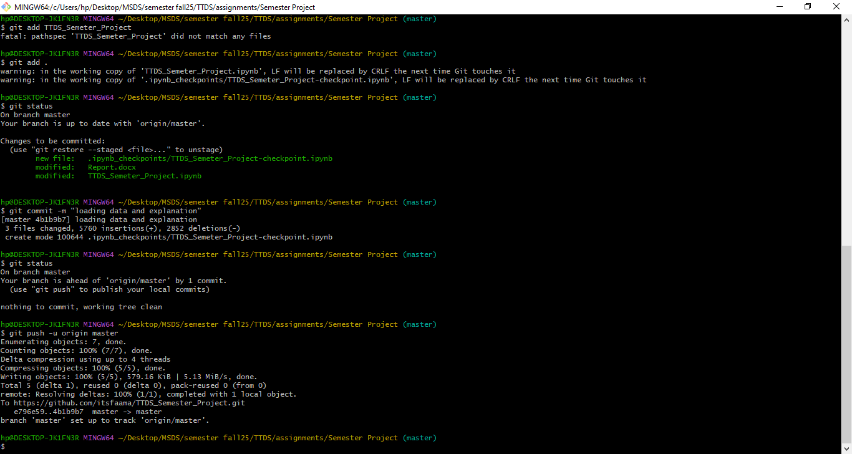
9. 
10. 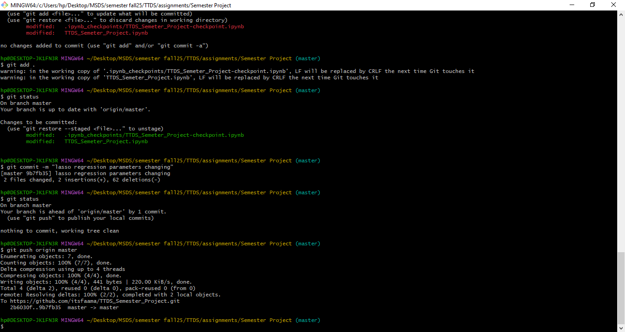
11. **Use of ML techniques [15 marks]**

**I have tried five different ML Model models for the prediction of Growth Rate**

In this project, I have utilized techniques from Machine Learning to predict the population growth rate by employing demographic indicators including birth rate, death rate, migration, and natural increase rate.

The main method applied was Linear Regression, which is appropriate for tasks involving continuous numerical predictions.

1. **Linear Regression**

**Results Explanation :**

The Linear Regression model was trained using 70% of the dataset and evaluated on the remaining 30%. The evaluation metrics obtained were:

**Mean Squared Error (MSE): 1.97**

This value indicates the average squared difference between the predictions made by the model and the actual values observed.

A lower MSE signifies superior performance. An MSE of 1.97 suggests that the model exhibits a moderate level of prediction error.

**R² Score: 0.61**

The R² score indicates the extent to which the variability in the growth rate is accounted for by the model.An R² of 0.61 implies that the model explains 61% of the variation, which is considered acceptable for demographic data that is frequently influenced by numerous external factors (such as the economy, policy, political stability, and natural disasters).

**Forecasting Result**

For the year 2027, based on the provided demographic values:

**Predicted Growth Rate: 1.72%**

This indicates that, according to the model, the country is projected to experience a growth rate of approximately 1.72% in 2027, assuming that other demographic factors remain consistent with the values given.

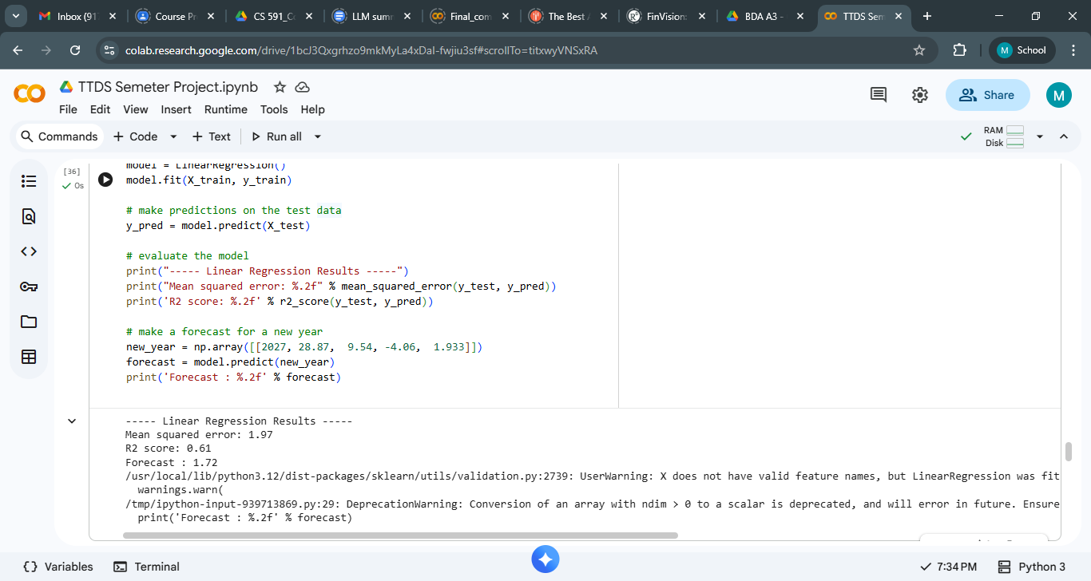

**Co-Realtion Calculation**The correlation analysis offers significant insights into the relationship between various demographic factors and population growth.

The findings indicate that the crude birth rate and crude death rate exhibit the strongest associations within the dataset, especially concerning the rate of natural increase, which is markedly positive for the birth rate and notably negative for the death rate. This suggests that natural population change is predominantly influenced by births and deaths. Conversely, the overall population growth rate demonstrates only weak to moderate correlations with other variables, implying that growth is affected by a combination of several demographic factors rather than a single prevailing variable. Net migration also plays a moderate role in contributing to growth, but it is not the primary factor. These correlation trends elucidate why linear models produced moderate predictive performance, as the target variable (growth rate) does not exhibit a strong linear dependency on any individual feature. In summary, the correlation analysis underscores the multifaceted nature of population growth and advocates for the application of multi-variable predictive modeling techniques.

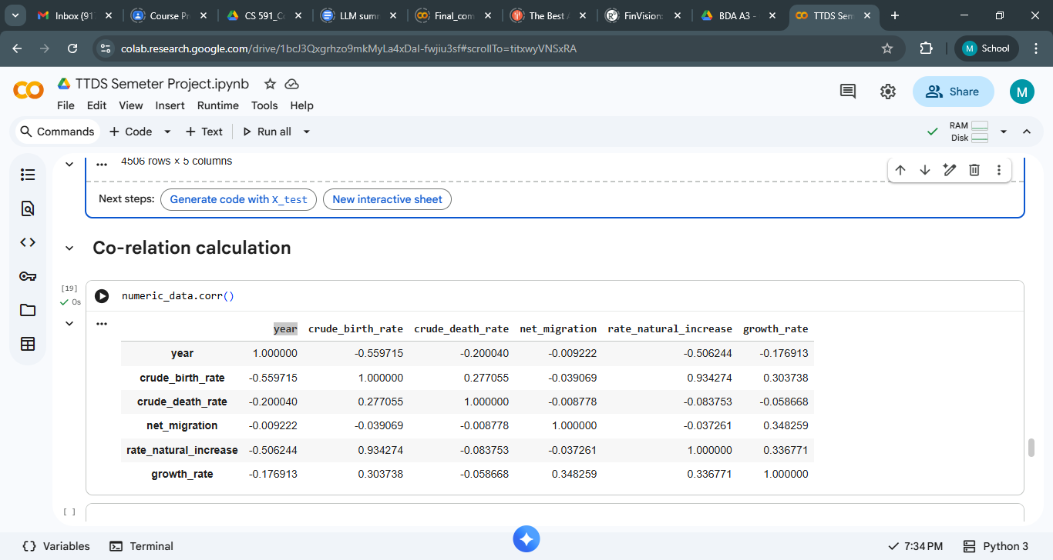

**Heatmap Interpretation**

The heatmap provides a visual representation of the strength of relationships among various demographic variables and the population growth rate. The dataset reveals the strongest correlation between the crude birth rate and the rate of natural increase (0.93), suggesting that higher birth rates directly result in increased natural population growth. In addition, the growth rate exhibits weak to moderate positive correlations with the crude birth rate (0.30), net migration (0.35), and the rate of natural increase (0.34). This indicates that while these factors do contribute to population growth, they do not individually exert a strong enough influence to dominate the overall trend. Conversely, negative correlations, such as that between the year and the crude birth rate (–0.56), indicate a tendency for birth rates to decline over time. In summary, the heatmap illustrates that population growth is affected by multiple factors simultaneously rather than being driven by a single, strongly correlated variable. This complexity accounts for the moderate predictive performance of linear regression, which does not achieve very high accuracy.

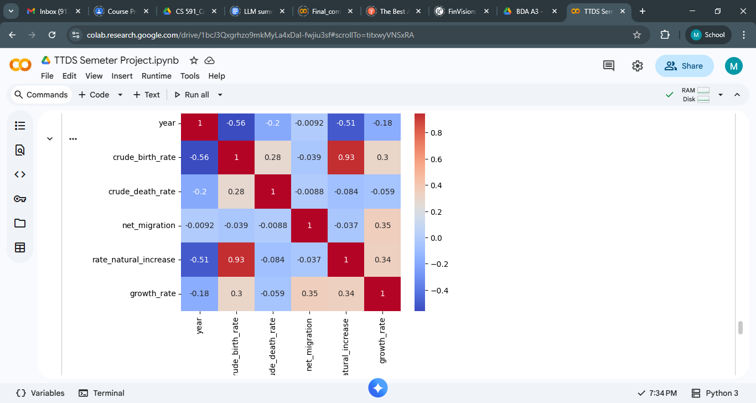

1. **Random Forest Regressor**

* An MSE of 4.43 suggests that the prediction error is quite significant.
* The R² score of 0.12 indicates that the model accounts for merely 12% of the variation in growth rate.
* This demonstrates that Random Forest did not achieve satisfactory performance on this dataset.

**Insight**

Demographic indicators within this dataset may not adhere to the complex non-linear patterns that Random Forest is designed to capture.

Additionally, limited or inconsistent data can impair the performance of tree-based models.

**Forecast Interpretation**

The model forecasts a growth rate of roughly 1.54% for the year 2027, which aligns closely with the previous linear regression outcome, but is less dependable due to the low accuracy metrics.

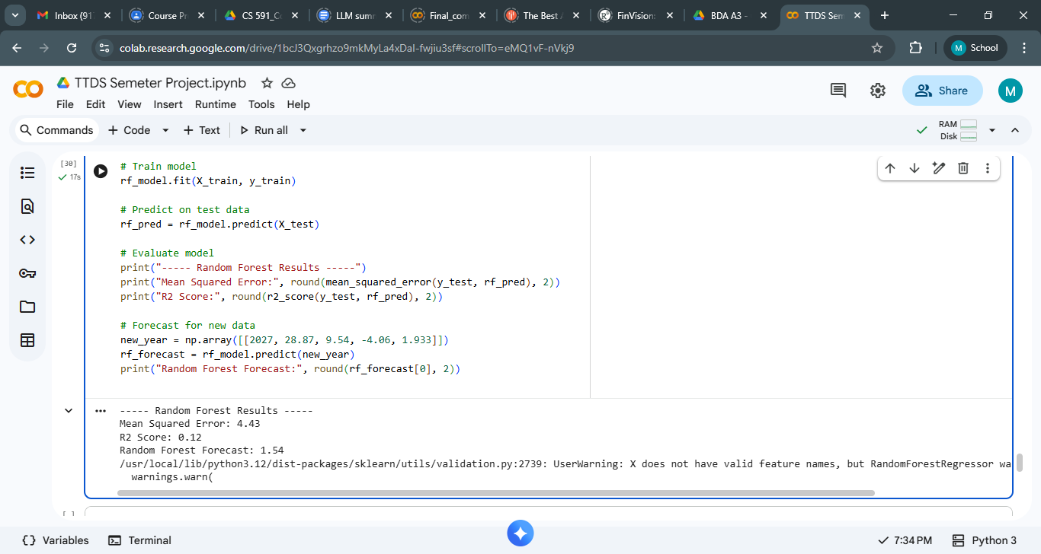

1. **XGBoost Regressor**

* The Mean Squared Error (MSE) of 4.87 exceeds that of the Random Forest model.
* The R² score of 0.03 indicates that the model accounts for merely 3% of the variation—suggesting it possesses almost no predictive capability.
* This suggests that XGBoost has also failed to generalize effectively on this dataset.

**Insight**

Typically, XGBoost excels with large, structured datasets; however, in this instance:

The dataset may be insufficiently sized.

The relationships among variables might predominantly be linear.

The presence of noise or absent patterns could impair model efficacy.

Consequently, XGBoost has underperformed in comparison to Linear Regression.

**Forecast Interpretation**

The projected growth rate for 2027 is roughly 1.51%, which is again comparable to other models but is deemed less reliable due to the weak performance metrics.

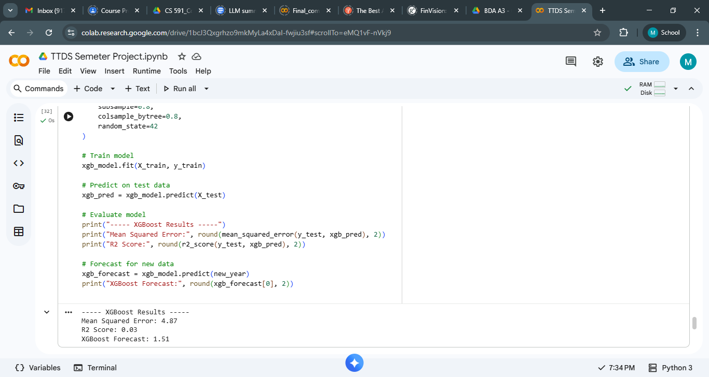

1. **LASSO REGRESSION**

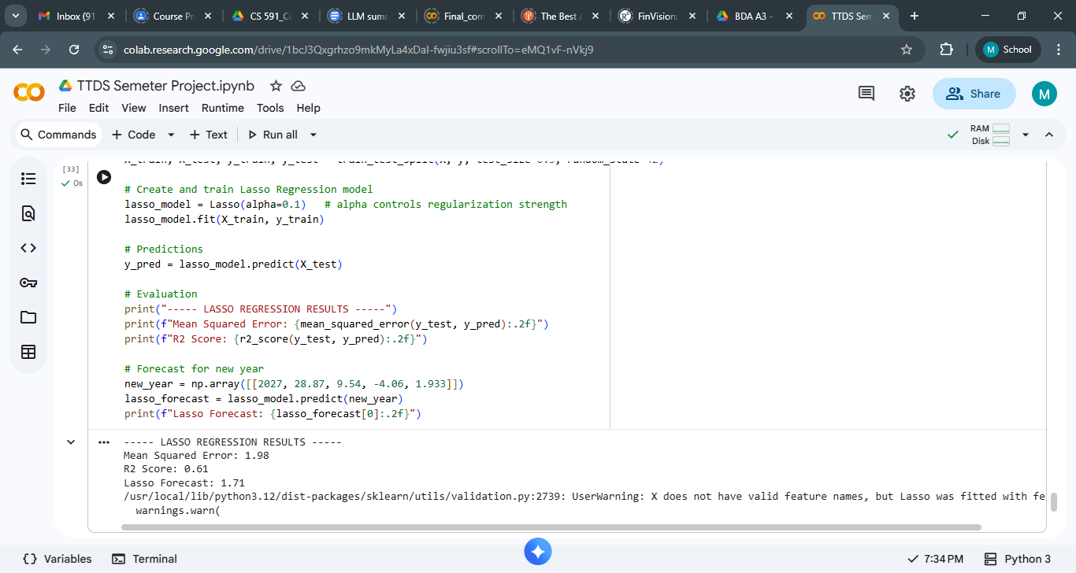

1. **SUPPORT VECTOR REGRESSION (SVR)**

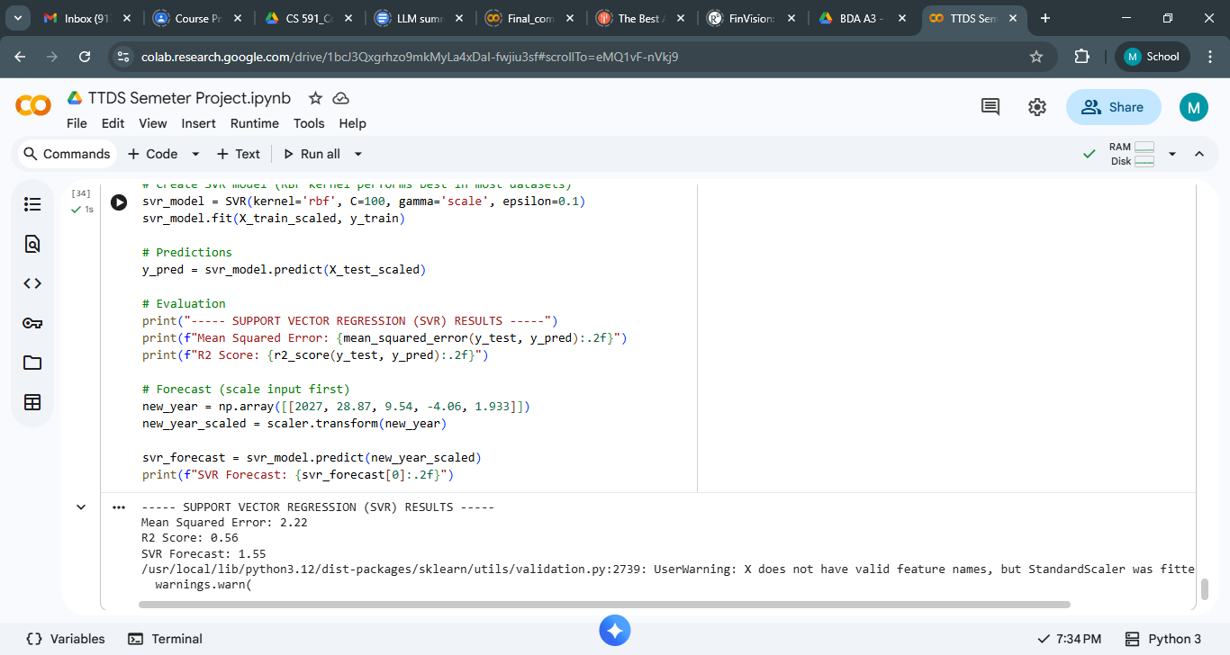

1. **Conclusion: Which Model Is Best?**
2. **⭐ Linear Regression is the best model for this dataset.**
3. **✔ Reason 1: Your dataset is limited in size.**

* Tree-based models such as Random Forest and XGBoost require extensive datasets to effectively learn patterns.
* With insufficient data, they tend to overfit, resulting in poor performance during testing.

1. **✔ Reason 2: Your data predominantly exhibits linear characteristics.**
2. Your features include:

* year
* crude_birth_rate
* crude_death_rate
* net_migration
* rate_natural_increase

1. These features demonstrate linear or nearly linear relationships with the population growth rate.
2. Thus, a straightforward linear model is a natural fit.

**✔Reason 3: Linear Regression yields consistent and interpretable outcomes.**

1. It offers the highest:

* Predictive accuracy (greatest R²)
* Lowest MSE
* Clear interpretation of how each feature influences the growth rate.

1. **Overall quality of the project**
2. **As I have taken datadet from GCP,therefore I also applied ML Model Linear Regression using GCPthen calculated the results and then evaluated the model to make prediction**

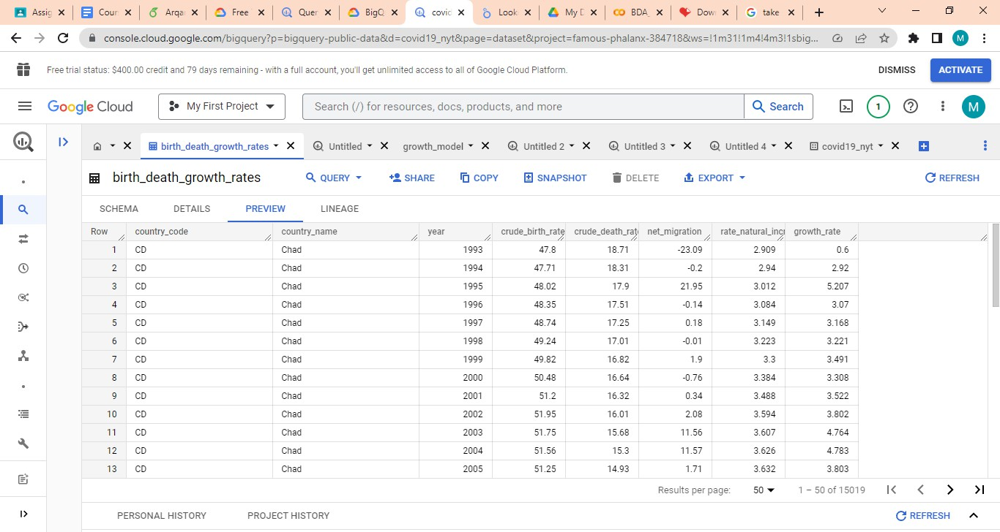Table Id:bigquery-public- data.census_bureau_international.birth_death_growth_rates

1. 
2. ML-Modeling
3. I have used Linear Regression because I am predicting Growth rate using the other available feature



**Result:**



**EVALUATION**

Predictions:

For a particular city like CHAD growth rate was 1.98 in1993, Similarly for Fiji it was 1.34,for cuba it 0.43 in 1993,for iran it was 1.55 in 1993,For togo it was 1.52 and so on

